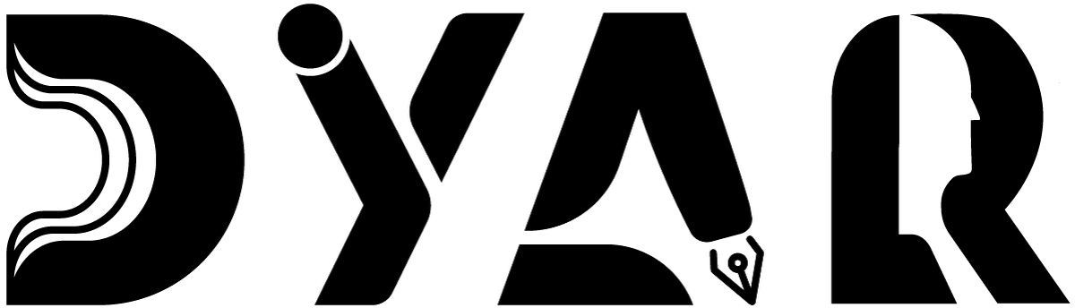
An NDIS Service Provider
RESOURCES HUB · FEEDBACK
Feedback & Complaints Process
How to tell DYAR what you think — four ways, anonymous option, what happens next.
Aligned to NDIS Practice Standards · NDIS Code of Conduct · NDIS Act 2013

Version 2 · 12 May 2026
DYAR Pty Ltd
NDIS Provider No. pending (Application 4-LRFP0J8) · ABN 68 695 255 504
Unit 1, 136 Main Street, Osborne Park WA 6017 · PO Box 8052, East Subiaco WA 6008
0470 540 306 · hello@dyar.com.au · Whadjuk Country

Feedback & Complaints Process
DYAR wants to hear what you think
Tell us anything
Tell us when things are GOOD.
Tell us when things are NOT good.
Tell us what could be BETTER.
You will NOT be in trouble. Your supports will NOT stop.
4 ways to give feedback
1. Phone
Call Mehdi: 0470 540 306
2. Email
hello@dyar.com.au
3. Online form
dyar.com.au/feedback
4. Tell your worker
Your support worker will pass it on.
You can be anonymous
You do NOT have to give your name.
Download the Anonymous Complaint Form from dyar.com.au/feedback.
What we do next
1. We say thank you within 2 business days.
2. We look into what you said.
3. We tell you what we will do.
4. We do it.
5. We follow up with you.
If you're not happy with our response
Contact:
• NDIS Commission — 1800 035 544
• OAIC (privacy) — 1300 363 992
• An independent advocate
Your voice changes how we work. We mean it. Tell us.
___________________________________________
DYAR Pty Ltd · ABN 68 695 255 504 · Unit 1, 136 Main Street, Osborne Park WA 6017 · 0470 540 306 · hello@dyar.com.au · dyar.com.au · Whadjuk Country · V1 19 May 2026

